

Segment Architecture Migration Plan
Version Number: 1.0
Version Date: <mm/dd/yyyy>

Notes to the Author

[See the FEA Segment Architecture Methodology (FSAM) (http://fsam.gov/) for more guidance and examples.]

Revision History

This table records information regarding changes made to the document over time.

Version | Date | Organization/Point of Contact | Description of Changes
1.0 | <mm/dd/yy> | <Organization Identifier / Point-of-Contact Name> | Baseline Version

Table of Contents

1. Introduction 5
2. Implementation Overview 5
3. Sequencing Diagram 7
4. Sequencing Milestones 8
5. Reuse Summary 9
5.1 Exchange Package Definition and Reuse 9
5.1.1 [Information Exchange Package] Reuse 10
5.1.2 [Information Exchange Package] Reuse 10
5.2 Segment Reuse 10
5.3 Reused Business Capabilities 10
5.4 Reused Information Systems 11
5.5 Reused System Services 11
6. Referenced Documents 12
7. Glossary 12
8. Acronyms 14

List of Figures

Figure 1: Recommendation Implementation Overview 6
Figure 2: Transition Recommendation Sequencing Diagram 7

List of Tables

Table 1: Sequencing Milestones 8
Table 2: Referenced Documents 12
Table 3: Glossary 14
Table 4: List of Acronyms 14

Introduction
This document describes the migration plan which describes the findings in the form of the integrated steps required to take the recommendations and begin to prioritize, develop business cases or investment proposals, initiate projects, or develop policy.

The Segment Architecture deliverables are based on the Federal Enterprise Architecture (FEA) Segment Architecture Methodology (FSAM) which consists of:

- Segment Architecture Overview. This document defines the scope, mission, and other driving factors for the segment. A governance framework may be established.

- Segment Baseline Architecture. This document describes the baseline (i.e. as-is) architecture for the segment.

- Segment Target Architecture. This document describes the target (i.e. to-be) architecture for the segment.

- Segment Architecture Recommendations. This document describes the recommendations for the segment architecture. As part of the recommendations, this document highlights the gap between the baseline and target architecture.

- Segment Architecture Migration Plan. This document describes the approach and steps to migrate from the as-is state to the to-be state, thereby achieving the target architecture.

See the Segment Architecture Overview document for background information on segment architectures and how they relate to other architectures and the IT Investment Life Cycle.

Implementation Overview
Figure 1: Recommendation Implementation Overview depicts ‘what’ will be implemented, ‘when’ it will be implemented, and the associated costs for implementation in each year.]
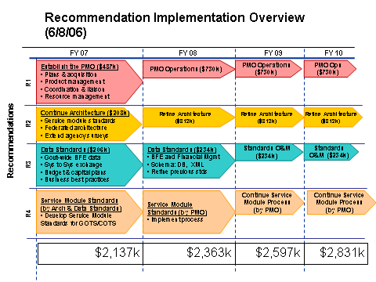

Figure 1: Recommendation Implementation Overview

Sequencing Diagram
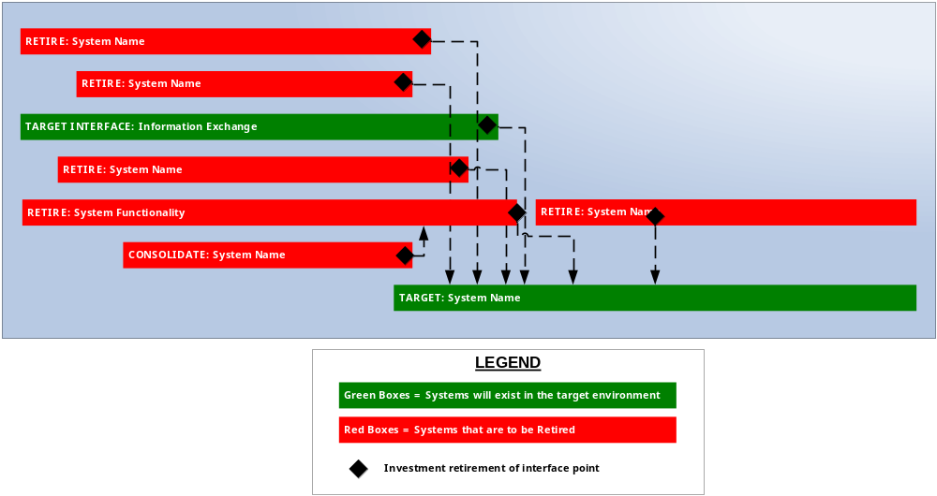

Figure 2: Transition Recommendation Sequencing Diagram

Sequencing Milestones
This section captures the recommendation sequencing milestones that can be incorporated into the segment transition plan once the recommendations are approved. The segment transition plan provides an integrated view of performance and schedule milestones for the segment.
Milestone ID | IT Investment, System or Program | Milestone Description | Target Completion Date | Actual Completion Date | Dependency ID | Dependencies/Constraints
Unique Identifier for the Milestone | Major IT investment or program related to the milestone. | Description of the milestone. | Target completion date for the milestone. | Actual completion date for the milestone, if applicable. | Enter the Milestone ID for the milestone for which the completion of this milestone is dependent upon. Note: Repeat as required for additional dependencies to the milestone. | Enter a description of the dependencies or constraints related to this milestone.
Table 1: Sequencing Milestones

Reuse Summary

Exchange Package Definition and Reuse
This section is used to document segment reuse of data that can be leveraged and reused from another segment. Data reuse consists of shared Data Reference Model (DRM) Exchange Packages which are composed of DRM Entities. Data Reuse includes:
- Data Exchange Packages – representing Information Sharing among segments (sharing does not require an information system intermediary)
- Data Entities – In the FEA DRM, a data exchange package is composed of one or more Data Entities. These may include things like Person, Facility, Claim, etc. The entity may be common across many agencies whether it is ever exchanged or not. If data exchange packages are reused, then the constituent Data Entities are reused by default.

Reused Exchange Package Name | Reused Exchange Package Description | Organizational Owner | Exchange Package Data Steward (Organization) | Owning Information System | Using Information System
Reused Information Exchange Name | Description of the Reused Exchange Package | Name (organization) of information provider / organizational owner for the exchange pkg. | Data steward for the exchange package. | Name of the information system that owns the reused exchange package | Name of the information system that uses the reused exchange package

[Information Exchange Package] Reuse
Reused Exchange Package Name | Reused Data Entity Name | Reused Data Entity Description | Entity Data Steward (Organization )
Reused Information Exchange Name | Reused data entity included in the exchange pkg. – use multiple rows for each entity in the exchange pkg. | Description of reused data entity included in the exchange pkg. | Data steward (organization) owning the reused data entity

[Information Exchange Package] Reuse
Reused Exchange Package Name | Reused Data Entity Name | Reused Data Entity Description | Entity Data Steward (Organization )
Reused Information Exchange Name | Reused data entity included in the exchange pkg. – use multiple rows for each entity in the exchange pkg. | Description of reused data entity included in the exchange pkg. | Data steward (organization) owning the reused data entity

Segment Reuse
Segment Name | Segment Reuse Explanation

Reused Business Capabilities
BRM Business Area | BRM Line of Business | BRM Sub-Function | Providing Organization

Reused Information Systems
System Name | System Description | System Owner | Segment

Reused System Services
Service Name | Service Description | System Name | System Owner

Referenced Documents
Table 2: Referenced Documents lists all documents used to arrive at and/or referenced within this document (e.g., related and/or companion documents, prerequisite documents, relevant technical documentation, etc.).

Document Name | Issuance Date
 | <Month Day, Year>
Table 2: Referenced Documents

Glossary
This section defines the terms used in the document that may be unfamiliar to readers of the document.
Term Name | Definition | Source
Baseline Architecture | Describes the current ("as is") state of the agency in terms of performance, business, data, services, and technology. | FEA
Business Architecture | A functional perspective of the overall agency EA, providing information about the agency's baseline and target architectures. Examples of elements are:  - Agency business processes, aligned to business sub-functions within the FEA BRM  - Internal and external participants (roles) within these business processes  - Linkage between agency business processes and agency-specific performance measurement indicators  - Linkage between business processes to agency service components  - Agency programs, linked to business processes  - Offices and facilities. | FEA
Business Services | Defined by the agency business model, business services include the foundational mechanisms and back-office services used to achieve the purpose of the agency, e.g., inspections and auditing, direct loans, program monitoring, and financial management. | FEA
Conceptual Solution Architecture | The conceptual solution architecture defines the segment systems and services (e.g., business and information exchange) including the supporting technical and service components. | FEA
Core Mission Areas | Unique service areas that define the mission or purpose of the agency. Core mission areas are defined by the agency business model (e.g., tactical defense, air transportation, energy supply, pollution prevention and control, and emergency response). | FEA
Data Model | A data model in software engineering is an abstract model that describes how data is represented and accessed. Data models formally define data objects and relationships among data objects for a domain of interest. | FEA
Enterprise Architecture | A management practice for aligning resources to improve business performance and help agencies better execute their core missions. An EA describes the current and future state of the agency and lays out a plan for transitioning from the current state to the desired future state. | FEA
Performance Architecture | A perspective of the overall agency EA that provides information about the agency's baseline and target architectures. Examples of elements are:  - Agency strategic goals and objectives (as per the agency's Strategic Plan and IRM Plan) and linkage between performance indicators and business processes  - Agency-specific performance measurement indicators aligned to the generic measurement indicators described in the FEA PRM  - Linkage between the agency's strategic goals and investments. | FEA
Segment | Individual elements of the enterprise describing core mission areas and common or shared business services and enterprise services. Segments are defined by the enterprise architecture. | FEA
Segment Architecture | Detailed results-oriented architecture (baseline and target) and a transition strategy for a portion or segment of the enterprise. | FEA
Service | Discrete unit of functionality that can be requested (provided a set of preconditions is met), performs one or more operations (typically applying business rules and accessing a database), and returns a set of results to the requester. Completion of a service always leaves business and data integrity intact. | FEA
Solution Architecture | An architecture for an individual IT system that is part of a segment. A solution architecture is reconciled to the segment architecture above it. | FEA
Stakeholder | A person, group, organization, or system who affects or can be affected by an organization's actions. | FEA
Target Architecture | Describes the future ("to be") state of the agency in terms of performance, business, data, services, and technology. | FEA
Table 3: Glossary

Acronyms
This section provides a list of acronyms and associated literal translations used within the document.
Acronym | Literal Translation
Table 4: List of Acronyms

